Appendix-1

Figure 9: 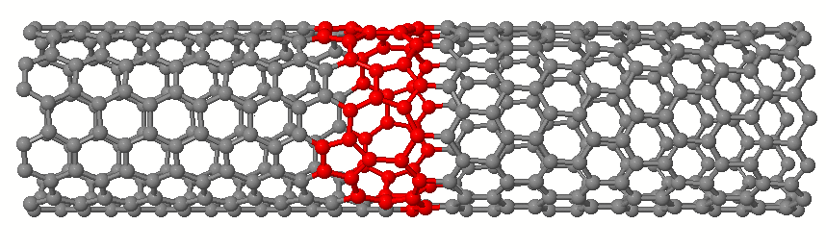(7,7)-(12,0) 448 atoms CNT Heterojunction

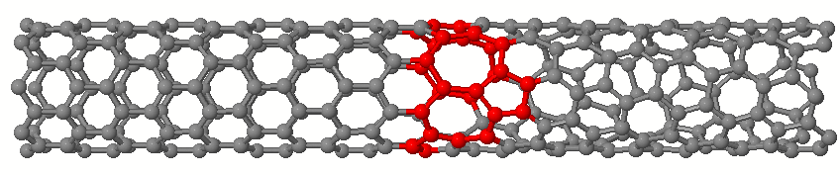
Figure 10: (8,0) – (6,3) 293 atoms CNT Heterojunction

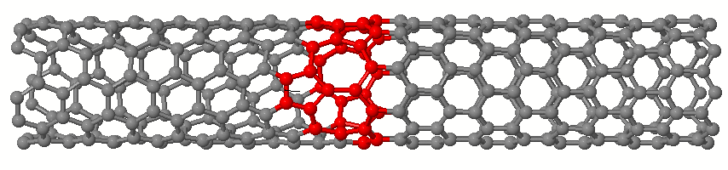Figure 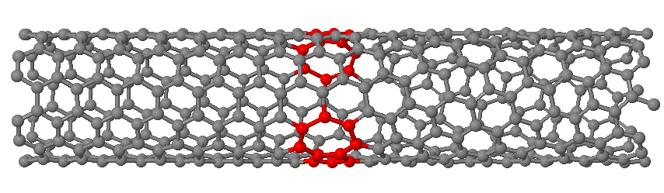11: (5, 5) – (9, 0) 329 atoms CNT Heterojunction
Figure 12: (6, 6) – (8, 4) 392 atoms CNT Heterojunction
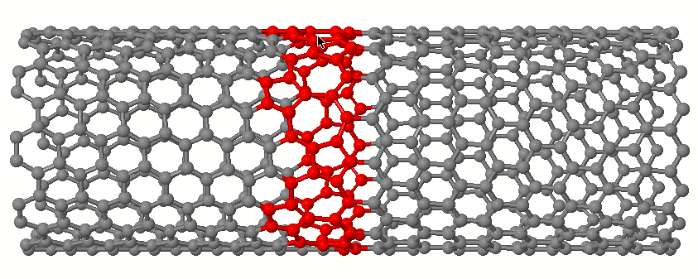Figure 13: (10, 10) – (17, 0) 637 atoms CNT Heterojunction

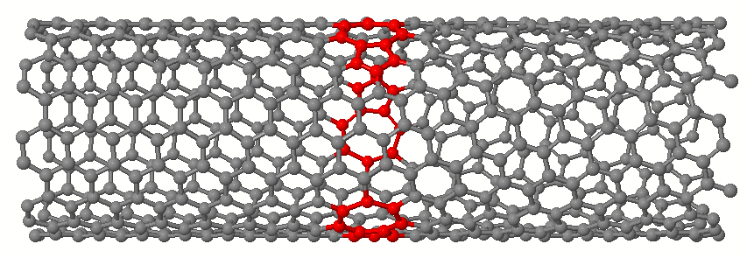 Figure 14: (9, 9) – (12, 6) 588 atoms CNT Heterojunction

