Letter of Confirmation to become Editorial Board Member

Name: SEMRA ŞARDAŞ

Designation & Affiliation: Professor, Head of the Toxicology Department and Drug Safety/Pharmacogenetics Unit

E-mail: semrasardas@gmail.com

Contact number: 0532 245 89 75

Area of Expertise: Drug metabolism, Pharmacogenetics, DNA damage / repair and Adverse drug reactions.

Consent Form
I, Dr./Prof SEMRA ŞARDAŞ am willing to become an Editorial Board member for the “Journal of Medical Toxicology Research” and have understood that I shall fulfil basic requirements for the Journal. I shall satisfy the regular responsibilities bestowed upon me as an Editorial Board Member. I shall be prompt in responding the communications received from the journal office. I assure to follow the standard publication ethics as an Editor. I shall not be biased in taking decision on articles assigned to me and promise to maintain the quality.

Please provide your specific consent as per the requirement:
- I have required academic and professional experience to become Editorial Board Member (Yes/No)…Yes……
- I will stand by the rules and regulations following the guidelines provided by the publisher (Yes/No) Yes………
- I will render my service to benefit the journal for 2/3/4/5 years (Yes/No)…Yes……
- I will help in soliciting quality manuscript(s) from my colleagues and peers (Yes/No) Yes………
- I will recommend the Journals to my colleagues and peers (Yes/No)…Yes……

I shall be available to complete timely review for the assigned articles. I shall also support the Journal related promotional activities. As an Editorial board member, I will encourage authors to publish manuscripts in the Journal.

Signature:
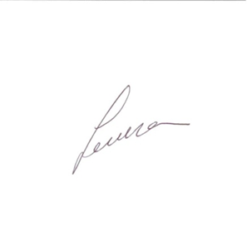
18 September 2017

Place:Marmara Unıversity,Faculty of Pharmacy,Toxicoşogy Department-Istanbul-Turkey

